SFAX UNIVERSITY
ERASMUS+ PROGRAMME
INTERNATIONAL CREDIT MOBILTY-ICM
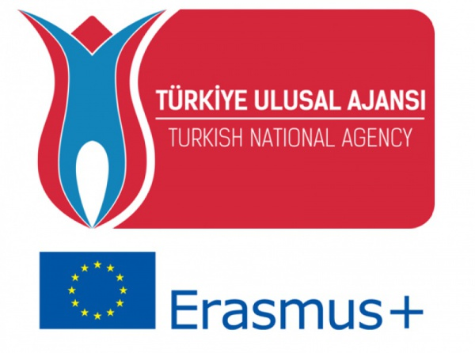

INTERNATIONAL CREDIT MOBILTY-ICM
APPLICATION FORM FOR STUDENTS MOBILITY FOR STUDIES
Name- Surname: | Gender: M F |  | PHOTO
Date- Place of birth:  dd/mm/yyyy ……………….. | Nationality:
Home country: | Home university:
Erasmus Code or city: | Passport-National ID number:
Intended term of study:  Fall Spring Both | Field of study:
Level of study:  Bachelor  Master Doctorate | Year of study:  1 2  3 4
E-mail: |  | Telephone:
Address:
Contact person for emergency: |  | Do you have any special needs (disability)?  Yes (+10 pts) No
Contact telephone/e-mail for emergency:

Departmental coordinator at home university | Institutional coordinator at home university
Name-Surname: | Name-Surname:
E-mail: | E-mail:
Signature/Date: | Signature/Date/Stamp:
I certify that the information given in this application is true, complete, and accurate to the best of my knowledge.
Student’s name-surname: Date:

Student’s signature:

Please attach Europass CV, Copy of National Identity Card, Transcript and English Proficiency Document forms
Please attach the “Disability” status documents if necessary.

